**Assignment 1.1**

1. Write a program to print “Hello World” on the screen.

**Ans:**

#include <iostream>

using namespace std;

int main()

{

cout<<"Hello World";

return 0;

}

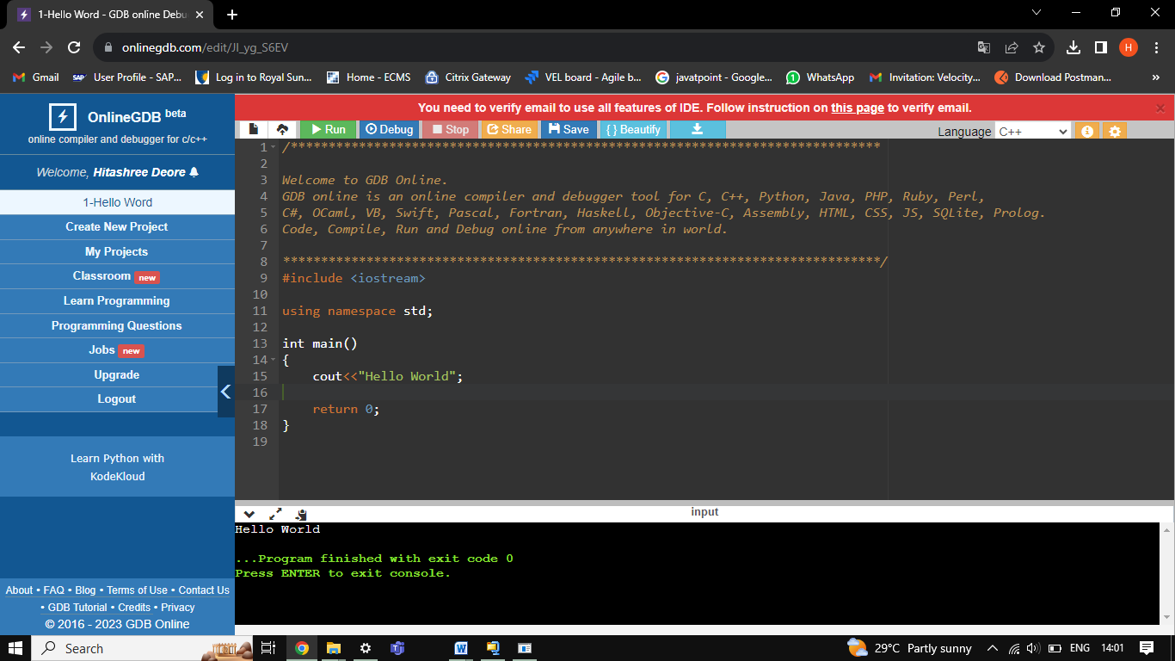

1. Write a program that generate the following output

10, 20, 19

Use an integer constant for 10, an arithmetic operator to generate the 20, and a decrement operator to generate 19.

**Ans:**

#include <iostream>

using namespace std;

int main()

{

int a, b, c;

a= 10;

cout<<a<<endl;

b= a*2;

cout<<b<<endl;

c= --b;

cout<<c<<endl;

return 0;

}

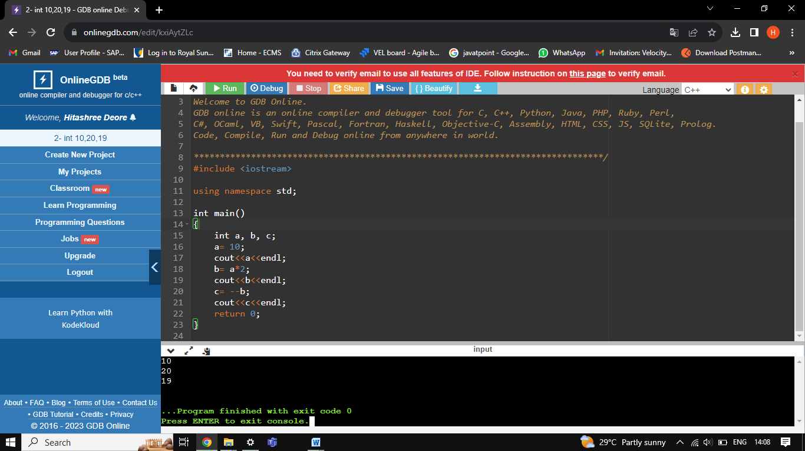

1. Write a program that asks the user to enter a radius value and then compute the volume of a sphere with the input radius.

**Ans:**

#include <iostream>

using namespace std;

int main()

{

int radius;

float volume;

float pie= 3.14;

cout<<"Enter the radius of sphere:";

cin>>radius;

volume= (4*pie*radius*radius*radius)/3;

cout<<"the volume of sphere is:"<<volume<<endl;

cout<<endl;

return 0;

}

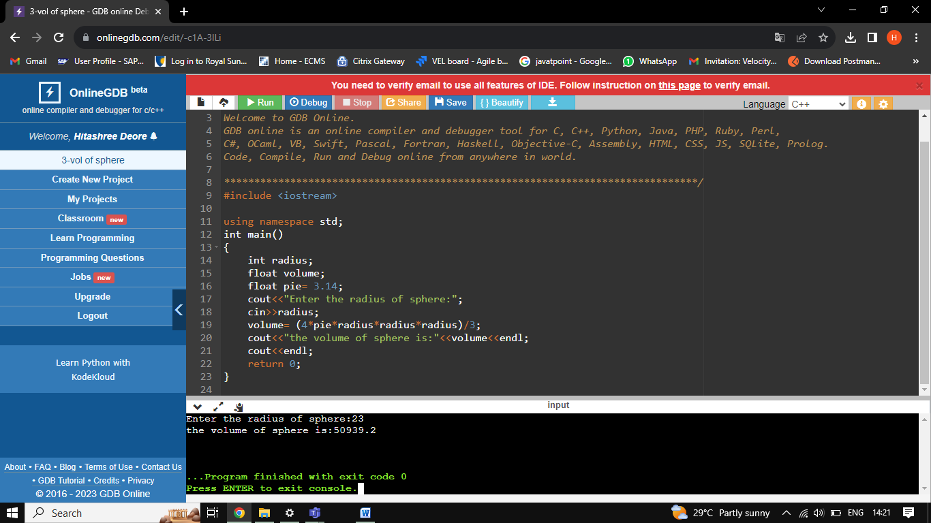

1. Write a program that takes three input of sides of a triangle. The program should indicate whether the triangle would be formed or not. If it can be formed it also indicates the type.

Ans:

#include <iostream>

using namespace std;

int main()

{

int side1, side2, side3;

cout<<"Enter side1:";

cin>>side1;

cout<<"Enter side2:";

cin>>side2;

cout<<"Enter side3:";

cin>>side3;

if (side1==side2 and side2==side3)

{

cout<<"Equilateral Triangle";

}

else if (side1==side2 or side2==side3 or side3==side1)

{

cout<<"Isosceles Triangle";

}

else

cout<<"Scalene Triangle";

}

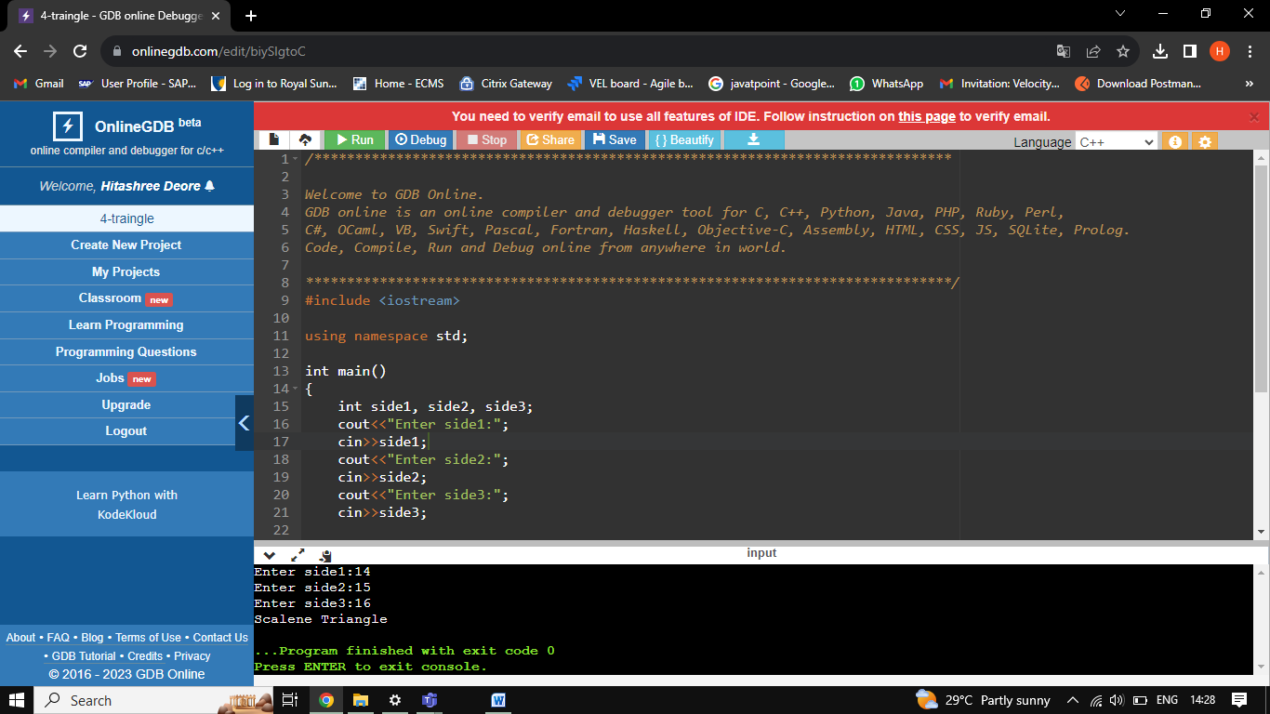

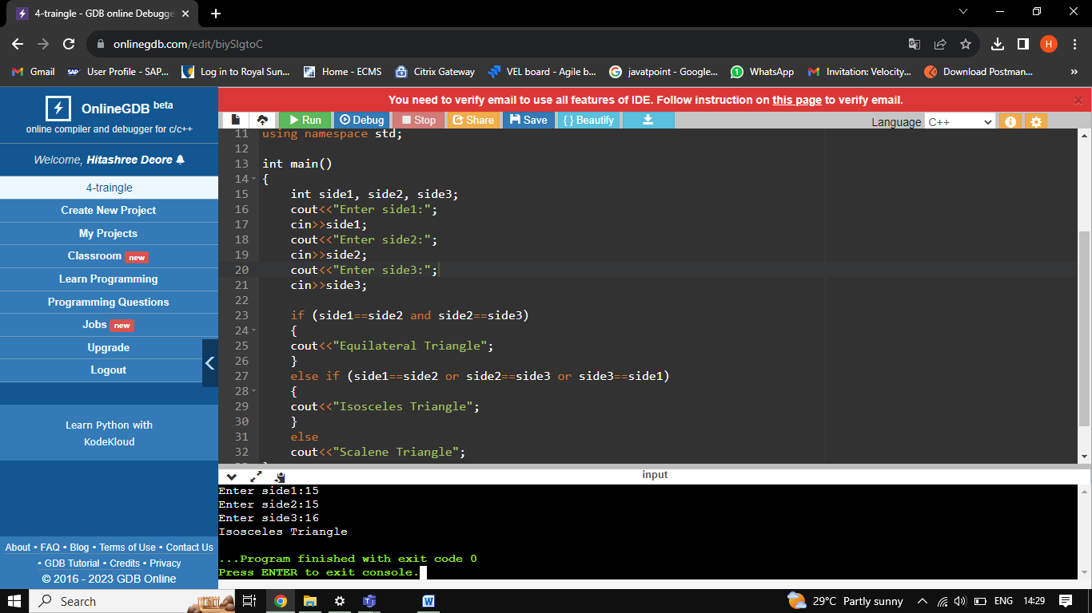

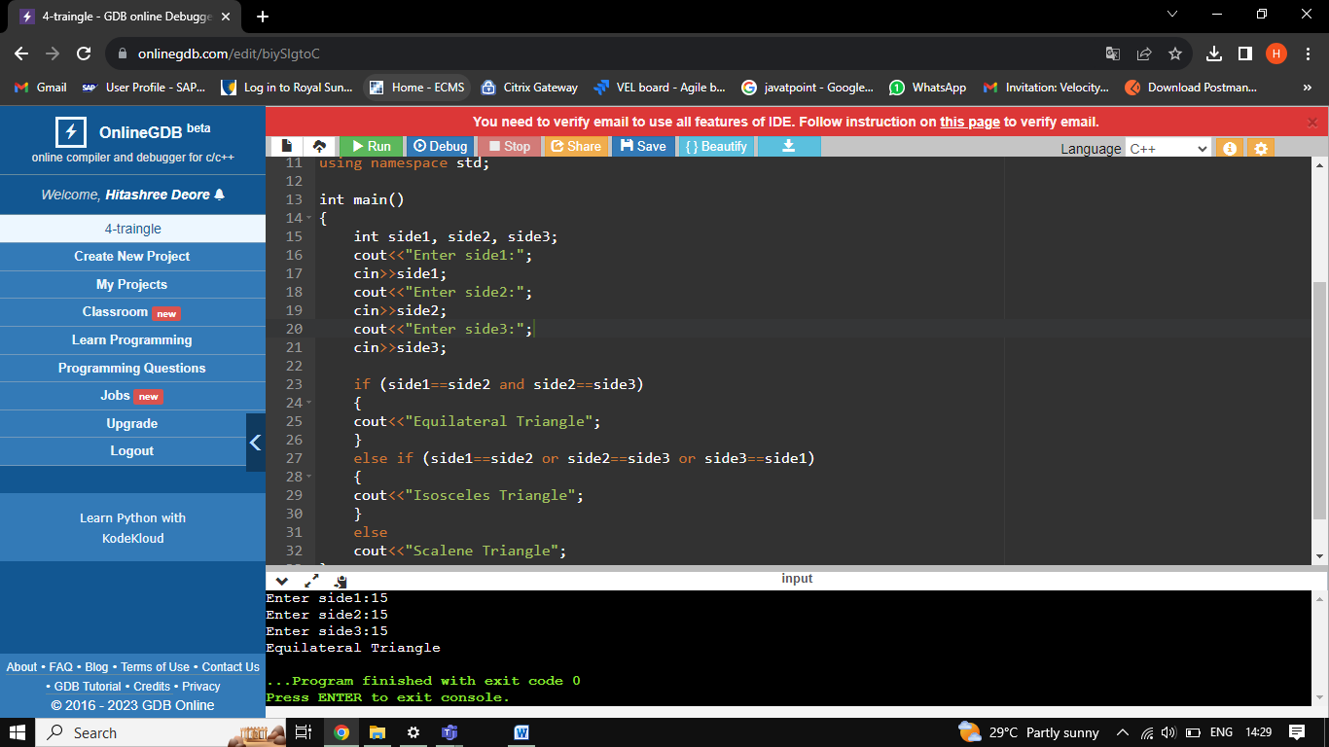

1. Write a program that takes one input as number and it will display whether the number is +ve, -ve or zero. If the number is +ve, then it will display whether the number is odd or even.

#include <iostream>

using namespace std;

int main()

{

int num;

cout<<"Enter the number:";

cin>>num;

if (num>0)

{

cout << "The number is positive"<<endl;

if (num%2==0)

cout<<"Given number is Even";

else

cout<<"Given number is Odd";

}

else if (num < 0) {

cout<<"The number is negative";

}

else

cout<<"Zero";

}

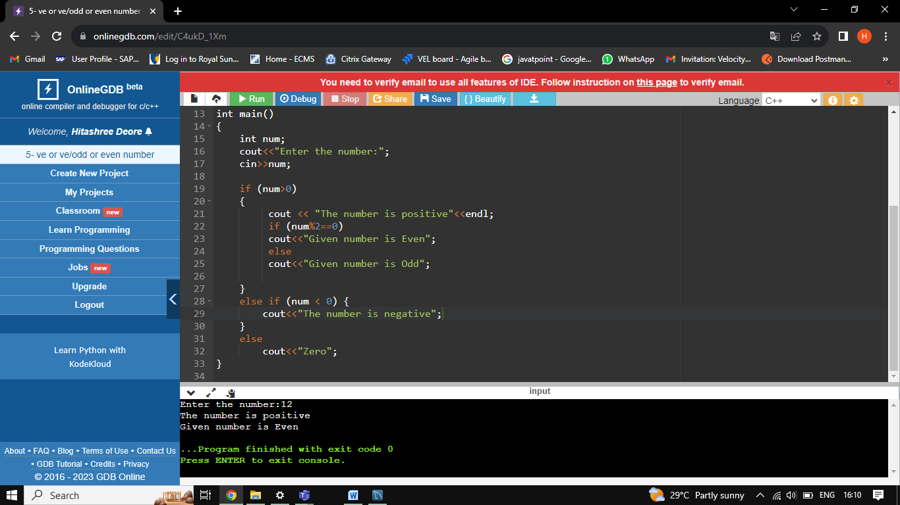

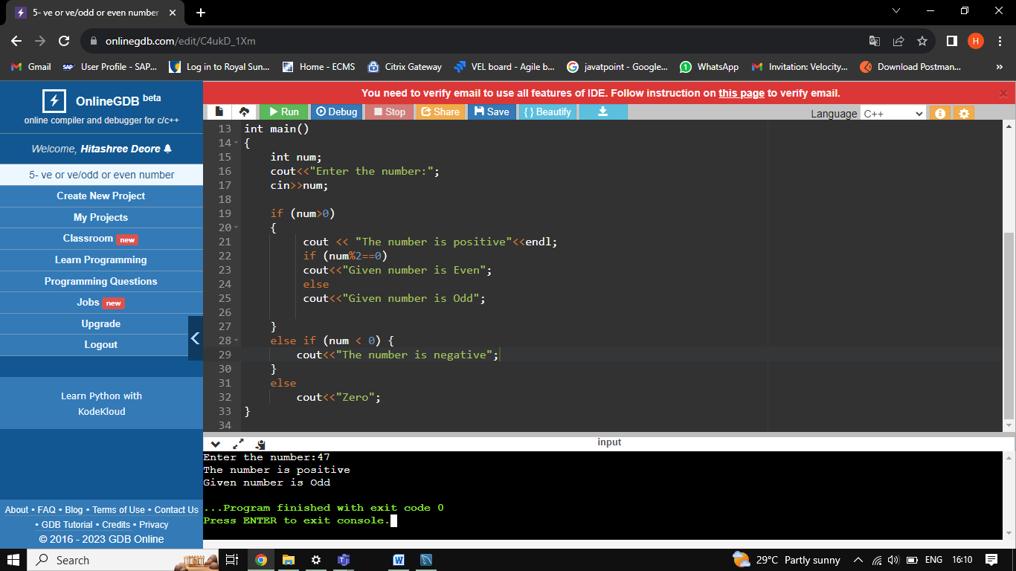

1. Write a program which takes username as input and it greets to user with his name.

#include <iostream>

using namespace std;

int main()

{

string name;

cout << "Enter Username:";

cin>>name;

cout<<"Hello "<<name<<" Welcome you";

return 0;

}

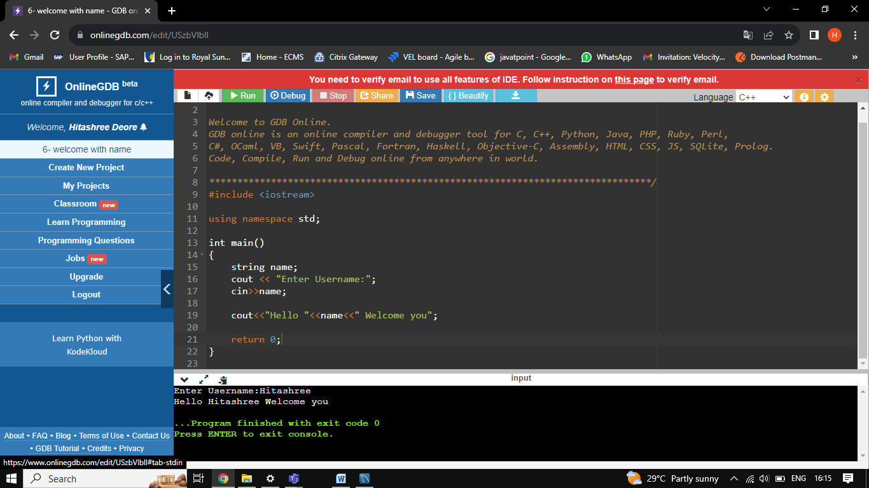

1. Write a program, which takes two integer numbers as input and it shows their exchanged value. (Don’t use third variable)

#include <iostream>

using namespace std;

int main()

{

int num1, num2;

cout << "Enter the first number : ";

cin >> num1;

cout << "Enter the second number : ";

cin >> num2;

cout<<"--------------------------------------"<<endl;

cout << "Values Before Swapping: "<<endl;

cout << "First Number = " << num1 <<endl;

cout << "Second Number = " << num2 <<endl;

cout<<"--------------------------------------"<<endl;

num1 = num1 + num2;

num2 = num1 - num2;

num1 = num1 - num2;

cout << "Values After Swapping: "<<endl;

cout << "First Number = " << num1 <<endl;

cout << "Second Number = " << num2 <<endl;

}

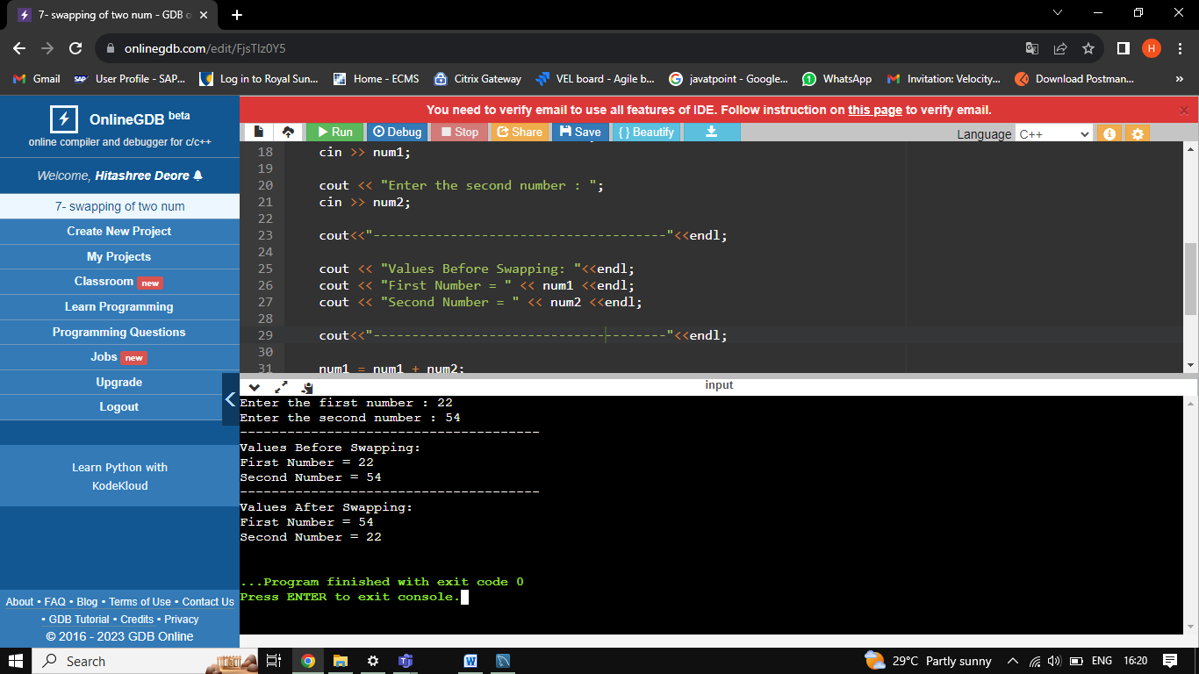

1. WAP to check Leap Year.

#include <iostream>

using namespace std;

int main()

{

int year;

cout<<"Enter the year: ";

cin>>year;

if(year%4==0)

{

cout<<"This is a Leap year"<<endl;

}

else

cout<<"This is not a Leap year"<<endl;

}

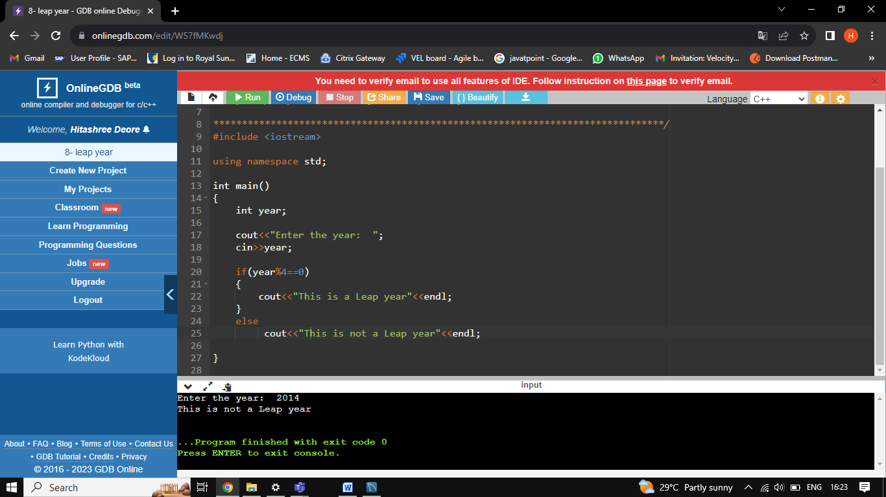

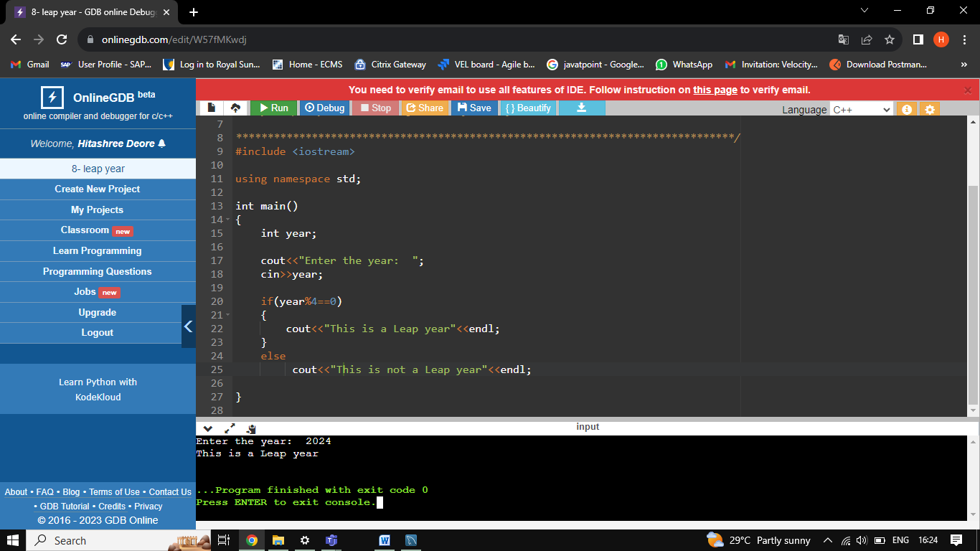

1. WAP for finding remainder of division of 2 numbers.

#include <iostream>

using namespace std;

int main()

{

int dividend, divisior, quotient, remaindr;

cout<<"Enter the dividend: "<<endl;

cin>>dividend;

cout<<"Enter the divisior: "<<endl;

cin>>divisior;

quotient= dividend / divisior;

cout<<"The quotient is: "<<quotient<<endl;

remaindr= dividend % divisior;

cout<<"The remaindr is: "<<remaindr;

return 0;

}

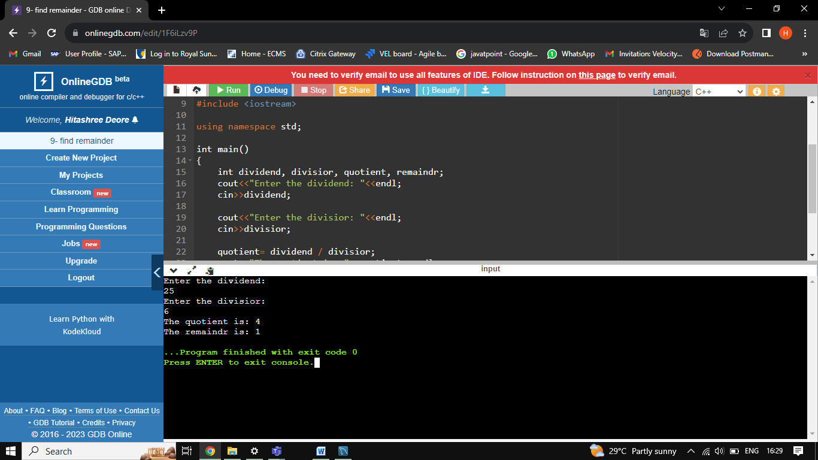

1. WAP to calculate Area of Rectangle.

#include <iostream>

using namespace std;

int main()

{

int length, breadth, area;

cout<<"Enter the length of rectangle: ";

cin>>length;

cout<<"Enter the breadth of rectangle: ";

cin>>breadth;

area=length*breadth;

cout<<"The area of the rectangle= "<<area;

return 0;

}

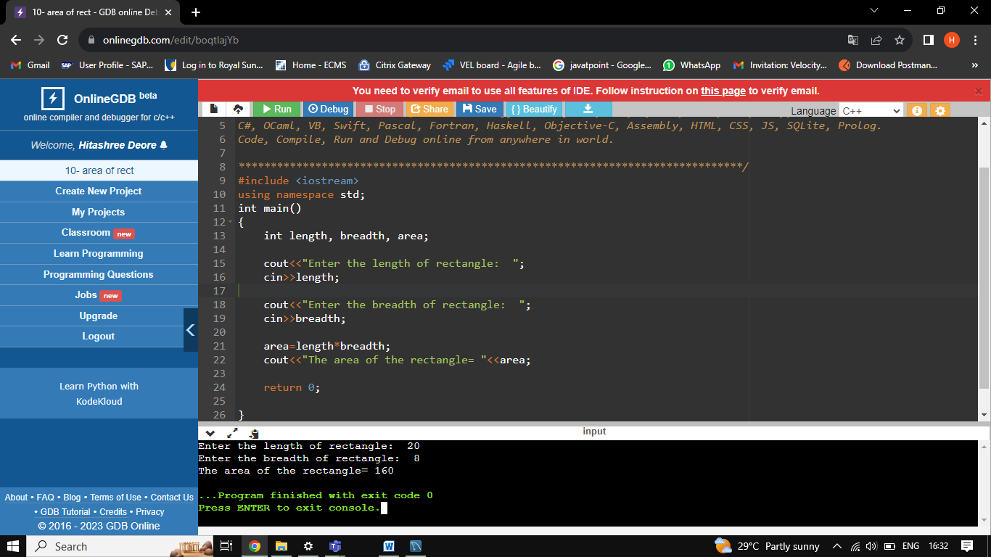

1. WAP to calculate Area of Square.

#include <iostream>

using namespace std;

int main()

{

int side, area;

cout<<"Enter the side of square: ";

cin>>side;

area= side*side;

cout<<"Area of square is: "<<area;

}

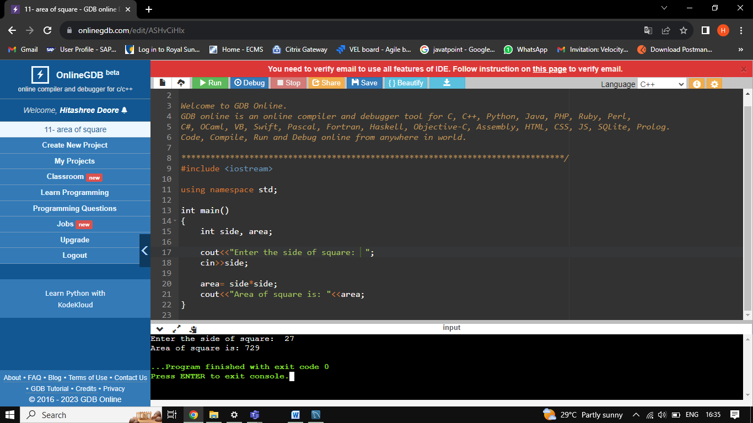

1. WAP to calculate the area of Triangle.

#include <iostream>

using namespace std;

#define Pie 3.141

int main()

{

float radius, area, circumference;

cout<<"Enter radius of circle: ";

cin>>radius;

area = Pie*radius*radius;

cout<<"Area of circle= "<<area<<endl;

circumference = 2*Pie*radius;

cout<<"Circumference of circle= "<<circumference;

}

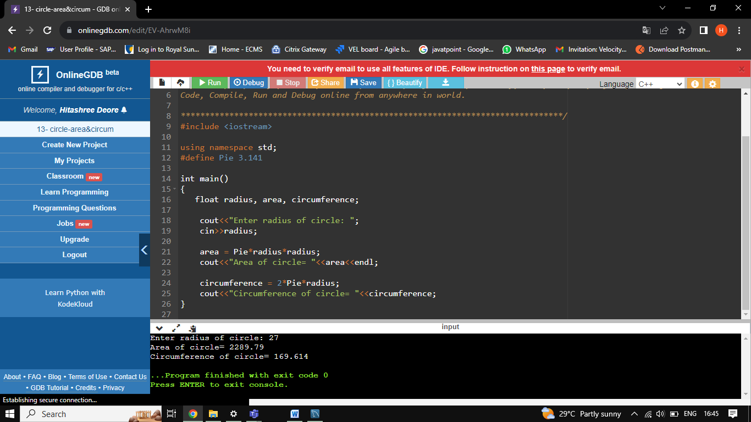

1. WAP to calculate Area and Circumference of Circle.

#include <iostream>

using namespace std;

int main()

{

float base, height, area;

cout<<"Enter the base of traingle: ";

cin>>base;

cout<<"Enter the height of traingle: ";

cin>>height;

area=(0.5)*base*height;

cout<<"Area of traingle= "<<area;

}

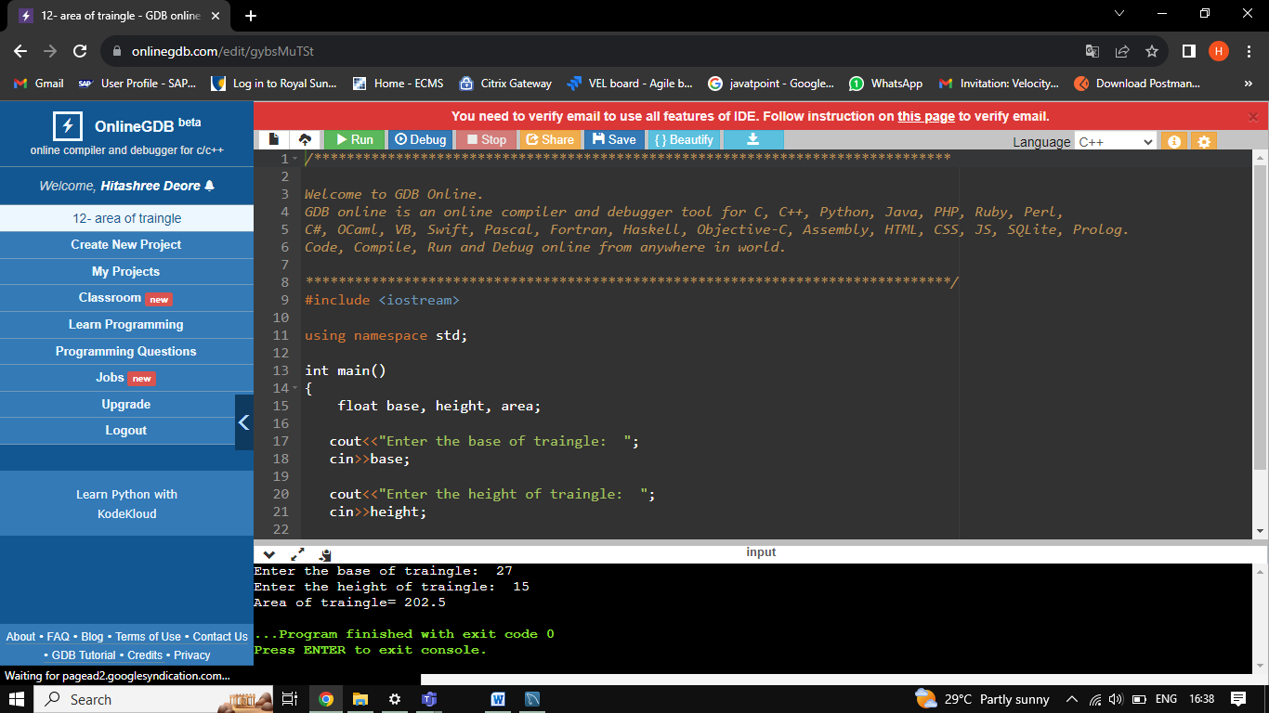

1. WAP for two item’s weight (floating points' values) and number of purchase (floating points' values) and calculate the average value of the items.

Test Data:   
Weight - Item1: 15  
No. of item1: 5   
Weight - Item2: 25   
No. of item2: 4   
Expected Output:   
Average Value = 19.444444

#include <iostream>

using namespace std;

int main()

{

float W1, W2, I1, I2, Avg;

W1= 15;

I1= 5;

W2= 25;

I2= 4;

Avg= ((W1 * I1) + (W2 * I2)) / (I1 + I2);

cout<<"The Average Value is: "<<Avg;

}

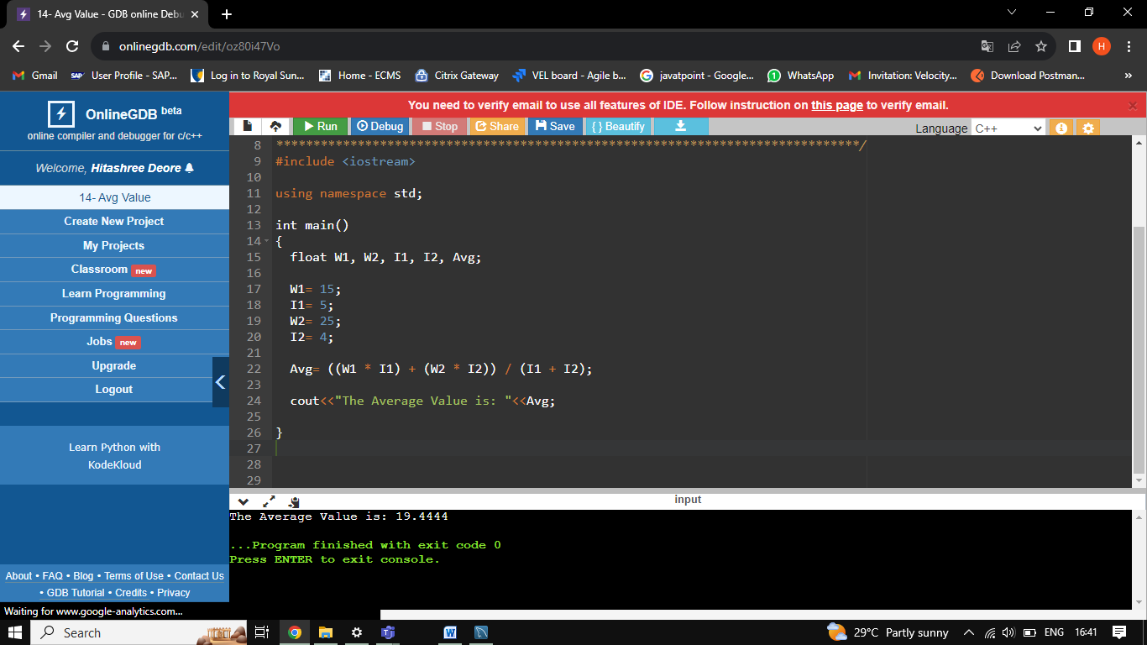

1. WAP to calculate a bike’s average consumption from the given total distance (integer value) travelled (in km) and spent fuel.

Test Data:   
Input total distance in km: 350   
Input total fuel spent in litres: 5   
Expected Output:  
Average consumption (km/lt) 70.00

#include <iostream>

using namespace std;

int main()

{

float dist, fuel, Avg;

dist= 350;

fuel= 5;

Avg= dist/fuel;

cout<<"The Average consumption of fuel is: "<<Avg;

}

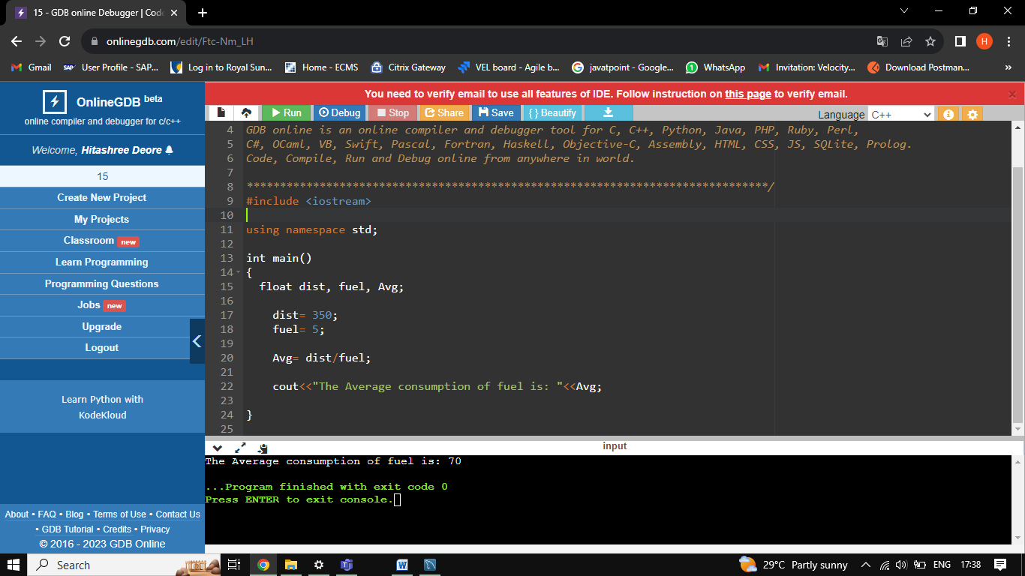

1. Write a program that will give the grade of the student based on the percentage he got in the course.

Use the following criteria for assigning grades:

Grade = A ( when percentage >= 60)

Grade = B ( when percentage >= 50 and percentage < 60)

Grade = C ( when percentage >= 40 and percentage < 50)

Grade = D ( when percentage >= 30 and percentage < 40)

Grade = E ( when percentage >= 20 and percentage < 30)

#include <iostream>

using namespace std;

int main()

{

float percentage;

cout<<"Enter the percentage: ";

cin>>percentage;

if(percentage >= 60)

cout<<" Grade A";

else if(percentage >= 50 and percentage < 60)

cout<<"Grade B";

else if(percentage >= 40 and percentage < 50)

cout<<"Grade C";

else if(percentage >= 30 and percentage < 40)

cout<<"Grade D";

else if(percentage >= 20 and percentage < 30)

cout<<"Grade E";

else

cout<<"Failed";

}

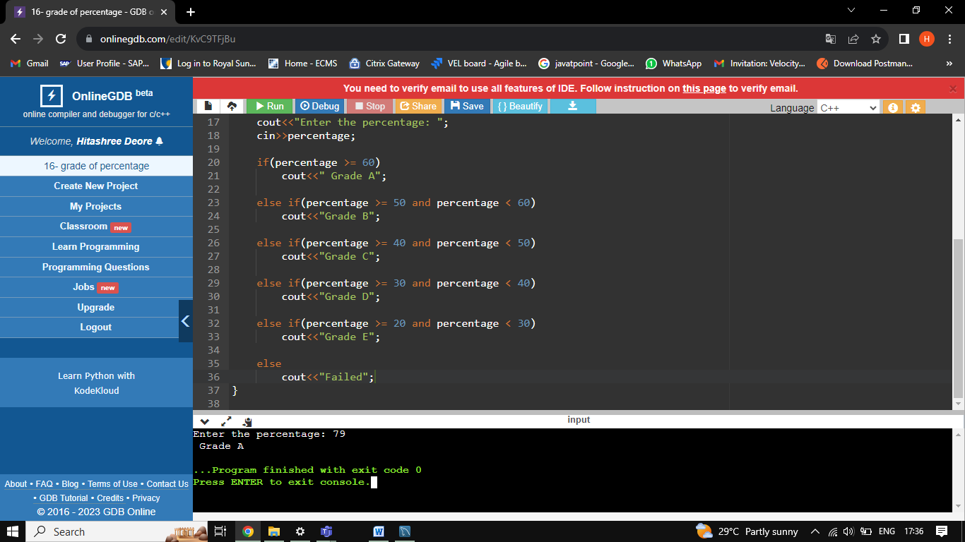

1. WAP to check whether a number is divisible by 5.

#include <iostream>

using namespace std;

int main()

{

int num;

cout<<"Enter the number: ";

cin>>num;

if(num%5==0)

cout<<"The given number is divisible by 5"<<endl;

else

cout<<"The given number is not divisible by 5";

return 0;

}

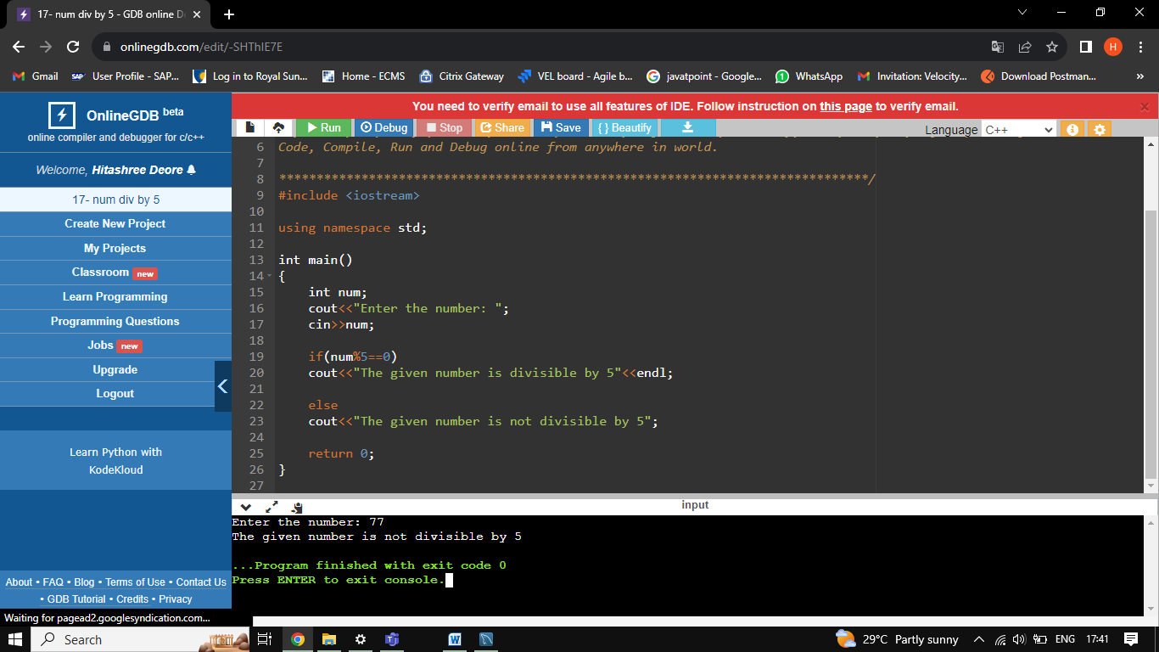

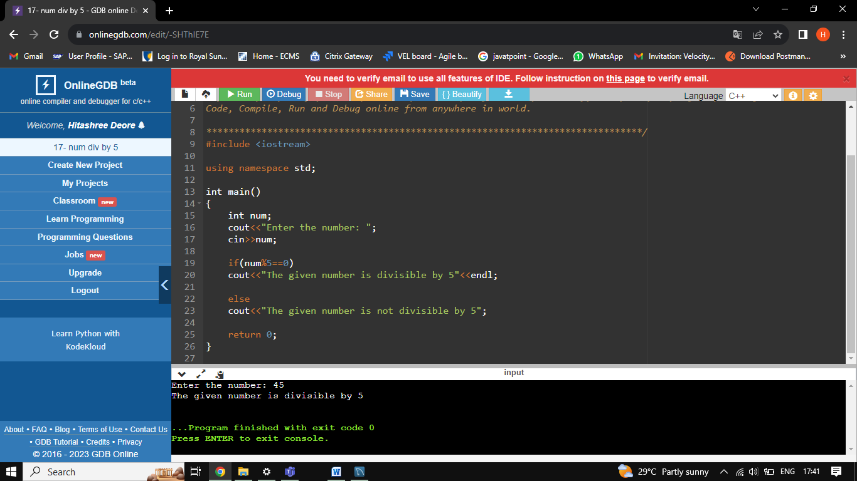

1. WAP to input basic salary of an employee and calculate its Gross salary according to following:  
   Basic Salary <= 10000 : HRA = 20%, DA = 80%  
   Basic Salary <= 20000 : HRA = 25%, DA = 90%  
   Basic Salary > 20000 : HRA = 30%, DA = 95%

#include <iostream>

using namespace std;

int main()

{

int sal, gross, hra, da;

cout<<"Enter the salary of the employee: ";

cin >> sal ;

if(sal<= 10000)

{

da=sal*20/100;

hra=sal*80/100;

gross=sal+da+hra;

cout<<"Gross salary of the employee is: "<<gross<<endl;

}

if(sal<= 20000)

{

da=sal*25/100;

hra=sal*90/100;

gross=sal+da+hra;

cout<<"Gross salary of employee is: "<<gross;

}

else if(sal>20000)

{

da=sal*30/100;

hra=sal*95/100;

gross=sal+da+hra;

cout<<"Gross salary of employee is: "<<gross;

}

else

{

cout<<"You have no salary"<<endl;

}

}

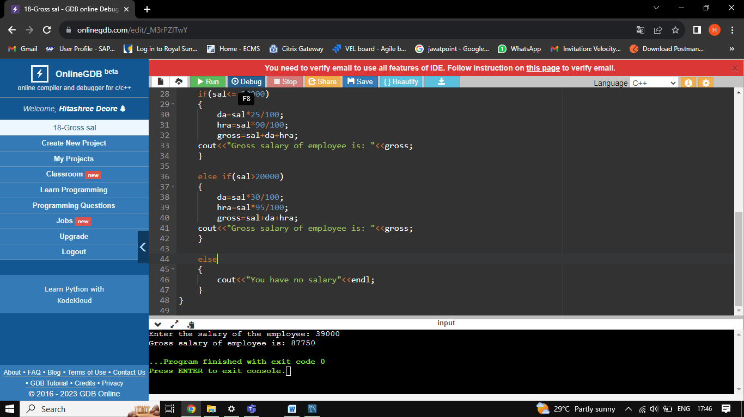

1. WAP to input electricity unit charges and calculate total electricity bill according to the given condition:  
   For first 50 units Rs. 0.50/unit  
   For next 100 units Rs. 0.75/unit  
   For next 100 units Rs. 1.20/unit  
   For unit above 250 Rs. 1.50/unit  
   An additional surcharge of 20% is added to the bill

#include <iostream>

using namespace std;

int main()

{

int unit;

float amnt, bill, surcharge;

cout<<"Enter the no. of units: "<<endl;

cin>>unit;

if(unit<=50)

{

amnt= unit*0.50f;

}

else if(unit<=150)

{

amnt= unit*0.75f;

}

else if(unit<=250)

{

amnt= unit*1.20f;

}

else

amnt= unit*1.50f;

surcharge= amnt*0.2f;

bill= amnt+surcharge;

cout<<"Total electricity bill: "<<bill<<endl;

return 0;

}

